**Django - Models**

**Example 1: Online shopping inventory of Ice-creams for class-based views**

**Example2: Online shopping inventory of Coffee for function-based views**

# **Create a database model**

Our first task is to create a database model where we can store and display ice-cream objects. Django will turn this model into a database table for us. Django imports a module models to help us build new database models, which will “model” the characteristics of the data in our database.

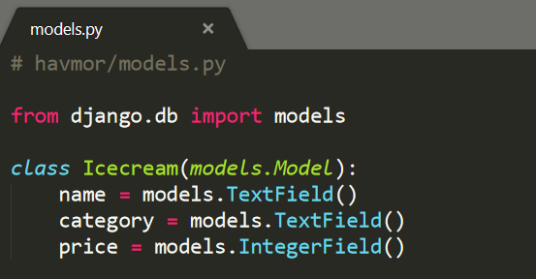

Fields : <https://docs.djangoproject.com/en/2.0/ref/models/fields/>

# **Activating models**

Whenever we create or modify an existing model we’ll need to update Django in a two-step process.

1. We create a migration file with the *makemigrations* command which generates the SQL commands for preinstalled apps in our INSTALLED_APPS setting. Migration files do not execute those commands on our database file, rather they are a reference of all new changes to our models. This approach means that we have a record of the changes to our models over time.
2. We build the actual database with migrate which does execute the instructions in our migrations file.

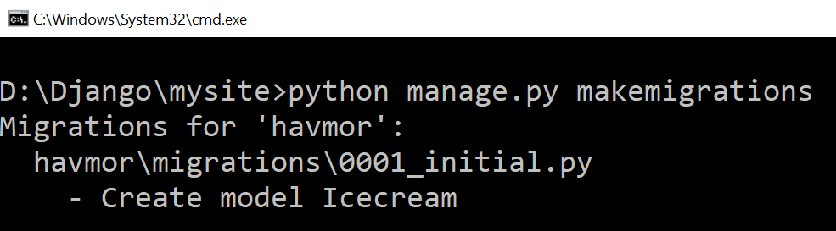

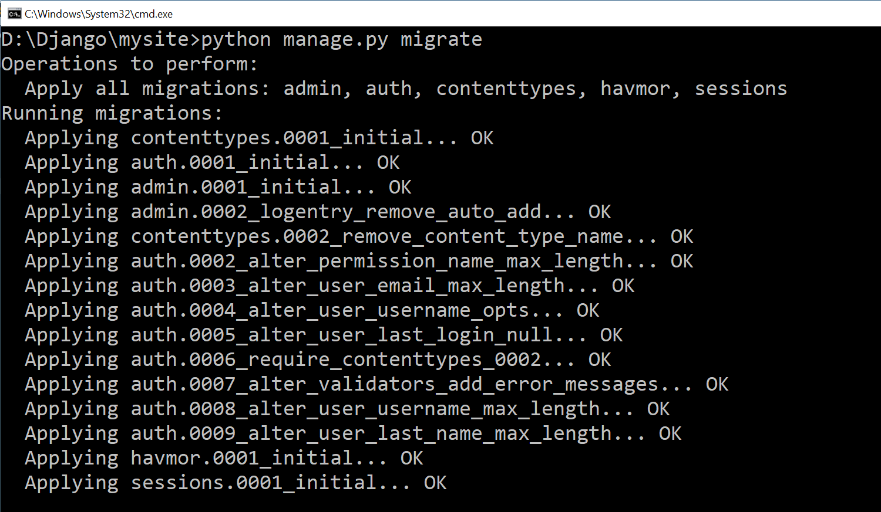

# **Views/Templates/URLs**

### **Class-based Views**

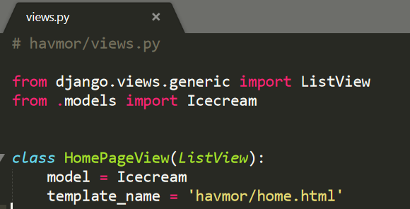

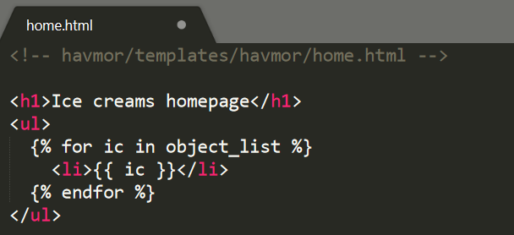

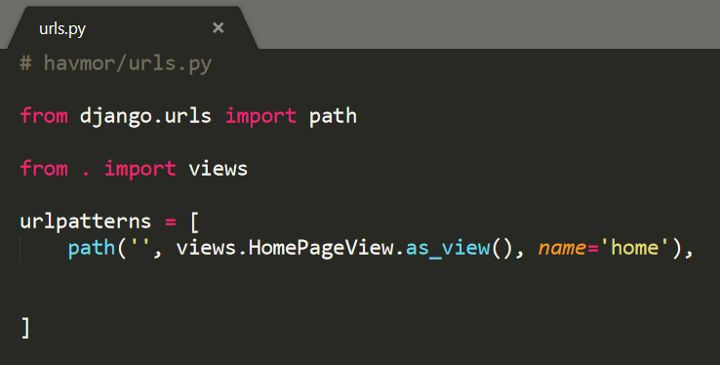

### **Function-based Views**

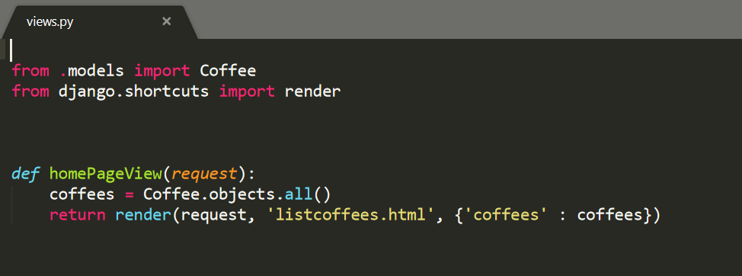

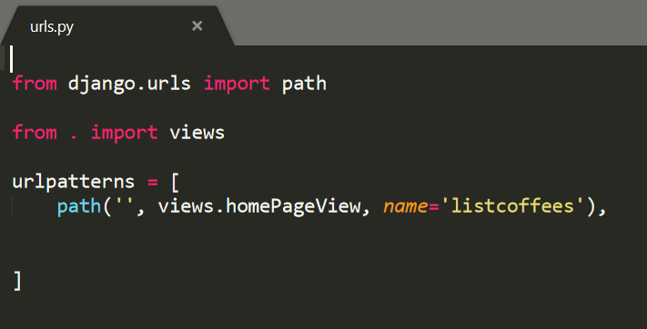

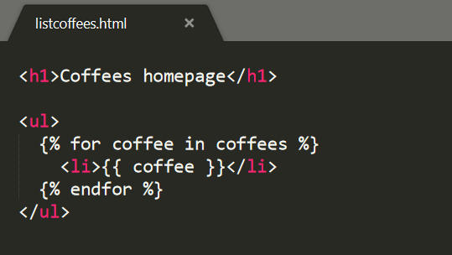

-------------------------------------------------------------------------------------------------------------------------------------------------------------

# **Django Admin**

Django provides us with a robust admin interface for interacting with our database. To use the Django admin, we first need to create a superuser who can login.

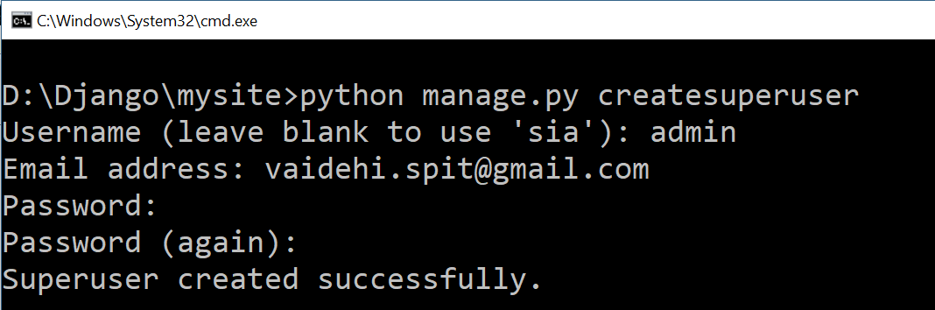

Restart the Django server with python manage.py runserver and in your browser go to http://127.0.0.1:8000/admin/. You should see the admin’s login screen:

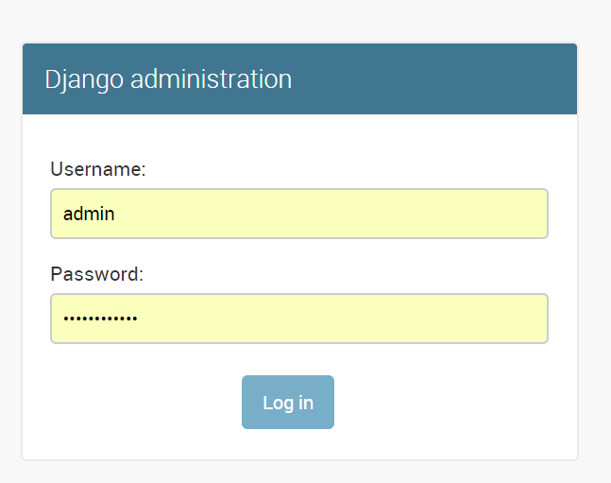

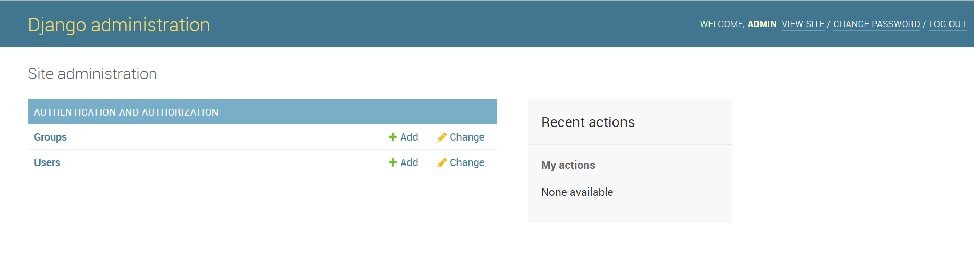

To make our models reflect into the admin view make following changes to admin.py file

